NAME:

PROBLEM 1:At a point in a loaded member, the stresses relative to a x-y-z coordinate system are given by:

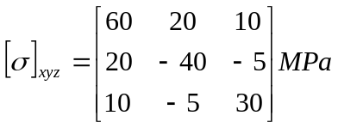

1a. Determine the principal stresses for this state of stress and their directions. (If you use MATLAB or Excel to perform calculations, be sure to print out the Command Window or spreadsheet that contains the commands you used to perform the calculations.)

1b. What angles (in degrees) do each of the principal stresses make with the x, y, and z axes?

σ₁: θ_{x}= θ_{y}= θ_{z}=

σ₂: θ_{x}= θ_{y}= θ_{z}=

σ₃: θ_{x}= θ_{y}= θ_{z}=

1c. What is the absolute maximum shear stress?

1d. What angles does the absolute shear stress make with the x, y, and z coordinates

τ_{max}: θ_{x}= θ_{y}= θ_{z}=

PROBLEM 2: A uniform bar of rectangular cross section 2hxb and specific weight γ hangs in the vertical plan. Its weight results in displacements

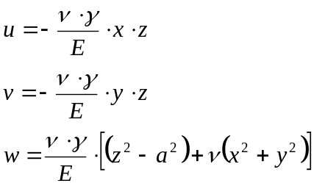

2a. Determine the normal strains ε_{x}, ε_{y}, and ε_{z}.

2b. Determine the shearing strains γ_{xy,} γ_{xz,} and γ_{yz.}

2c. Determine the rigid body rotations Θ_{xy}, Θ_{xz}, and Θ_{yz}.

2d. Given that the material under consideration is isotropic with modulus E and Poisson’s ration ν, determine the normal stresses σ_{x}, σ_{y}, an σ_{z}.

2e. Determine the shear stresses τ_{xy}, τ_{xz}, and τ_{yz}.

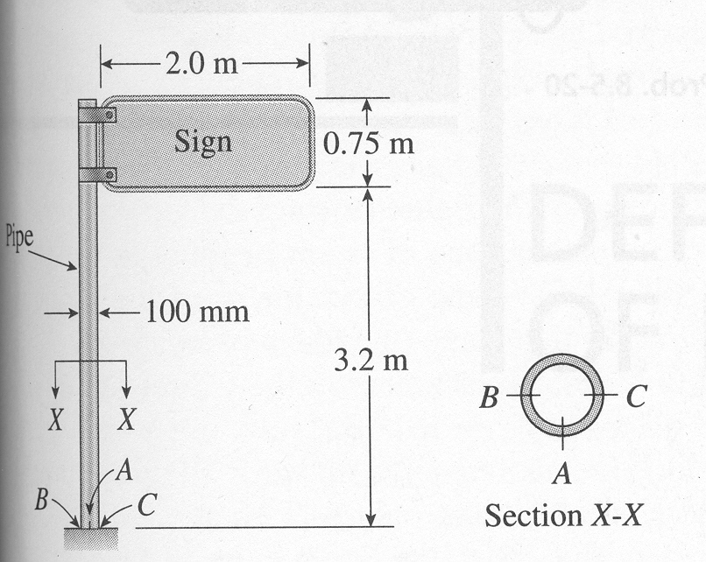
PROBLEM 3: A sign is supported by a pipe having outer diameter 100mm and inner diameter 80mm. The dimensions of the sign are 2m x 0.75m, and its lower edge is 3.2m above the base. The wind pressure against the sign is 1.8 kPa. Determine the absolute maximum shear stress in the pole.

